# Logo Description automatically generatedLogo Description automatically generatedRAILWAY FOOD DELIVERY APPLICATION

## PRODUCT DEVELOPMENT LABORATORY(19IT67C)

***Submitted by***

|  |  |
| --- | --- |
| **HARINI D** | **2015022** |

***in partial fulfillment for the award of the degree***

***of***

**BACHELOR OF TECHNOLOGY**

## IN

INFORMATION TECHNOLOGY

## NATIONAL ENGINEERING COLLEGE, KOVILPATTI-628 503

**ANNA UNIVERSITY: CHENNAI 600 025**

**APRIL 2023**

# ANNA UNIVERSITY: CHENNAI 600 025 BONAFIDE CERTIFICATE

Certified that this Product Development laboratory report “**RAILWAY FOOD DELIVERY APPLICATION**” is the bonafide work of **“HARINI D (2015022)”** who carried out the product development under my supervision.

|  |  |
| --- | --- |
| **SIGNATURE** | **SIGNATURE** |
| **Ms.V.Anitha, M.E.,** | **Dr.K.G.Srinivasagan, M.E., Ph.D.,** |
| **Assistant Professor** | **Head of the department** |
| Department of Information Technology | Department of Information Technology |
| National Engineering College | National Engineering College |
| K.R.Nagar, Kovilpatti–628503 | K.R.Nagar, Kovilpatti–628503 |
| Thoothukudi District, TamilNadu | Thoothukudi District, TamilNadu |

*Submitted for the practical examination held at National EngineeringCollege, K.R Nagar, Kovilpatti – 628503 on*

*…………………*

## INTERNAL EXAMINER EXTERNAL EXAMINER

**ACKNOWLEDGEMENT**

First and foremost, we would like to thank God Almighty for showering his blessings throughout our life. He has been the tower of our strength in each stepof our work. We take the privilege to express hearty thanks to our parents for their valuable support and effort to complete the project work.

We would like to express our deep sense of gratitude and respectful regards to our director **Dr.S.Shanmugavel, B.Sc., D.M.I.T., Ph.D.,** for giving an opportunity to do this work.

We would like to express our deep sense of gratitude and respectful regards to our director **Dr.K.Kalidasa Murugavel, M.E., Ph.D.,** for giving an opportunityto do this work.

We express our profound thanks to our beloved Head of the Department **Dr.K.G.Srinivasagan, M.E., Ph.D.,** for extending her full support and providing various facilities during the project work.

We would like to extend our profound thanks to our project guide **Ms.V.Anitha, M.E.,** Assistant Professor, Department of Information Technology, whose valuable guidance, technical support and suggestions helped us for doing the project work.

We express our sincere gratitude to our project faculty in-charges **Dr.S.Rajagopal, M.E., Ph.D.,** Assistant Professor(SG) and **Ms.V.Anitha, M.E.,** Assistant Professor, Department of Information Technology for their valuable guidance at each and every stage of the project.

We extend our hearty thanks to our tutors and class in-charges for their valuable guidance. We are grateful to all the staff members and our dear friends fortheirvaluable suggestion and co-operation for this project work.

**ABSTRACT**

The goal of the train meal delivery system is to give passengers a practical way to order food from restaurants while they are travelling. The system enables customers to place food orders from the eateries displayed on the screen and have it delivered to a nearby junction. The creation of a web application entails the integration of maps and the embedding of a QR code that is only functional during the voyage. The website is made to be convenient and user-friendly. The concept behind this meal delivery system is to allow travellers to experience fantastic eating without getting off the train or bringing food from home. This app will undoubtedly make travelling by train much more convenient.

**CHAPTER 1 INTRODUCTION**

Railway food delivery application is a revolutionary

web application that allows passengers to order and get food delivered to them while travelling on a train. In this modern era everything is being digitalized and every citizen in the country started ordering food online so, it could be better making it possible to order food online even while travelling. This application provides a wide range of food options from restaurants across the country. Users can choose their desired meal item or items and have it delivered to their seat using this system. Due to its speedy food delivery and elimination of the need for manual distribution, the application is also intended to be cost- effective. With the use of a QR code, this app also eliminates fraudulent ordering. Each seat's individual QR code will be created, and it will only be good for the duration of the trip. By eating their favourite foods from their favourite eateries, the customers can enjoy their journey. Passengers are not required to pack food from their homes for the trip or disembark at every junction to buy food. The passengers benefit from not having to scuffle through the mob. As people get down, it can be challenging for them to board the train before it departs. This web application can also help to solve this issue. By using this programme, the passengers can have a joyful and trouble- free journey. Passengers may easily order meals and conveniently pay for it because to the application's excellent usability and security.

## CHAPTER 2 SURVEY

**BACKGROUND STUDY:**

The Indian Railways is one of the largest railway networks in the world, serving millions of passengers daily. With long train journeys, food becomes a crucial aspect of the travel experience. Currently, the Indian Railways offers various options for onboard catering, including pantry cars, e-catering, and onboard catering by IRCTC (Indian Railway Catering and Tourism Corporation). However, passengers often face issues like unavailability of food, unhygienic food, and long waiting times for food delivery. To address these issues, a railway food delivery web application can be developed to provide a hassle-free food delivery service for passengers. The web application can offer a variety of food options, including regional cuisine and special meals for passengers with dietary restrictions. The application can also provide real-time tracking of food delivery, ensuring timely delivery of meals. Additionally, the application can offer payment options like online payment and cash on delivery. The development of such an application would require collaboration with the Indian Railways, IRCTC, and various food vendors. The application can leverage the existing infrastructure of the railways, including pantry cars and e- catering services, to ensure efficient food delivery. Overall, a railway food delivery web application can enhance the onboard food experience for passengers and address the challenges faced in the current catering system.

## CUSTOMER SURVEY:

Q1) How much often do you travel in train

1. Monthly Once
2. Twice a month
3. Rare case

Q2) What issues do you face when buy food in a junction when you travel in train?

* 1. Over crowd
  2. False ordering
  3. Faster departure of train

Q3)How do you feel when you buy your favourite dish from your favourite restaurants on the way of your journey?

Q4) Will it be useful for you to order food through an application while travelling?

1. Yes
2. No

Q5) Does QR code reduce False ordering and make the order and delivery easier?

1. Yes
2. No

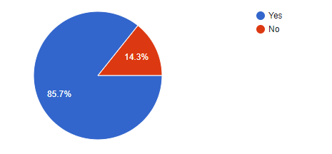

Fig 2.1 Customer suggestion for ordering food through mobile app

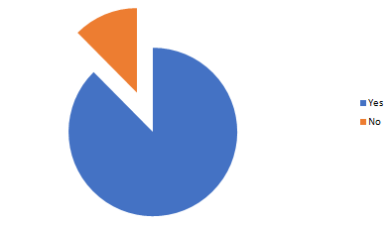

Fig 2.2 Customer suggestions for placing order using QR code.

.

## CUSTOMER JOURNEY MAP:

Customer journey maps are used to map the relationship between a customer and an organization over time and across all channels on which they interact with the business. Design teams use customer journey mapsto see how customer experiences meet customers’ expectations and find areas where they need to improve designs**.** The figure 2.3 shows the customer journey map for the railway food delivery application.

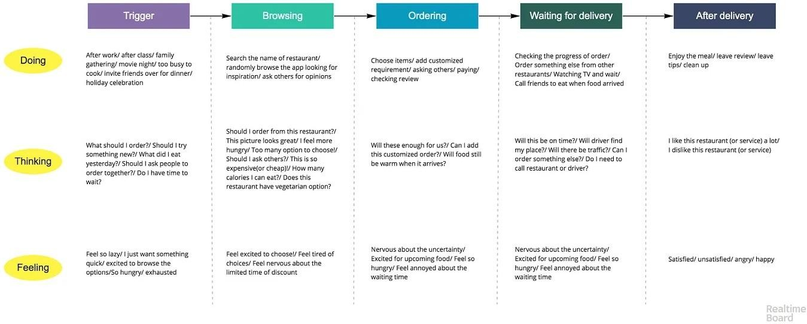

**Fig 2.3** Customer Journey Map for Railway food ordering app

## EMPATHY MAP:

An empathy map helps to map what a design team knows about the potential audience. This tool helps to understand the reason behind some actions a user takes deeply. This tool helps build Empathy towards users and helps design teams shift focus from the product to the users who are going to use the product.

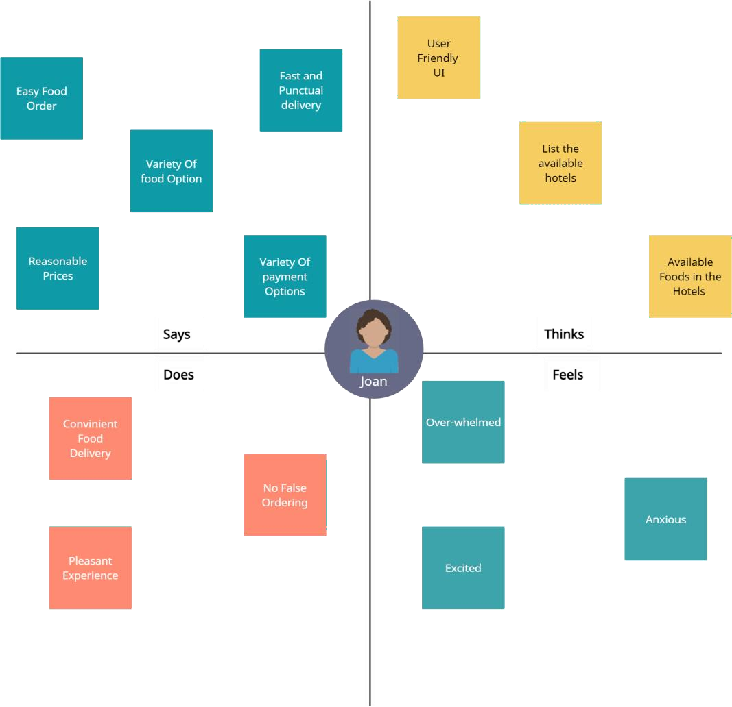

**Fig 2.4** Empathy Map for Railway food ordering app

## BLOCK DIAGRAM

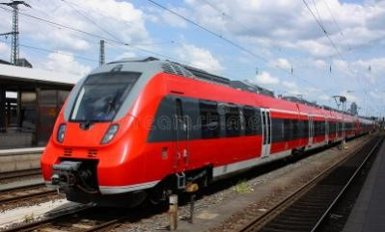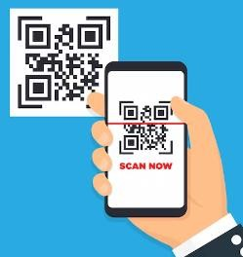

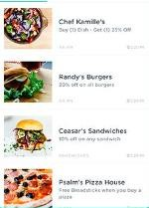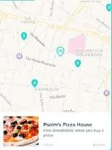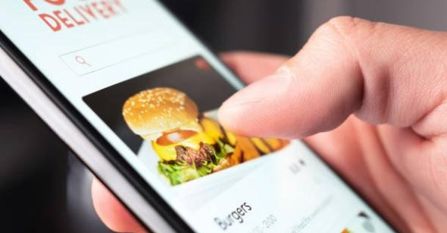block6.PNG

Block Diagram for Railway food ordering system

**CHAPTER III MODULES**

**Module – I**

The design of a straightforward home page with information on how to place an order for meals is the initial module of the website. The user should enter from and to points of the journey in the input field.

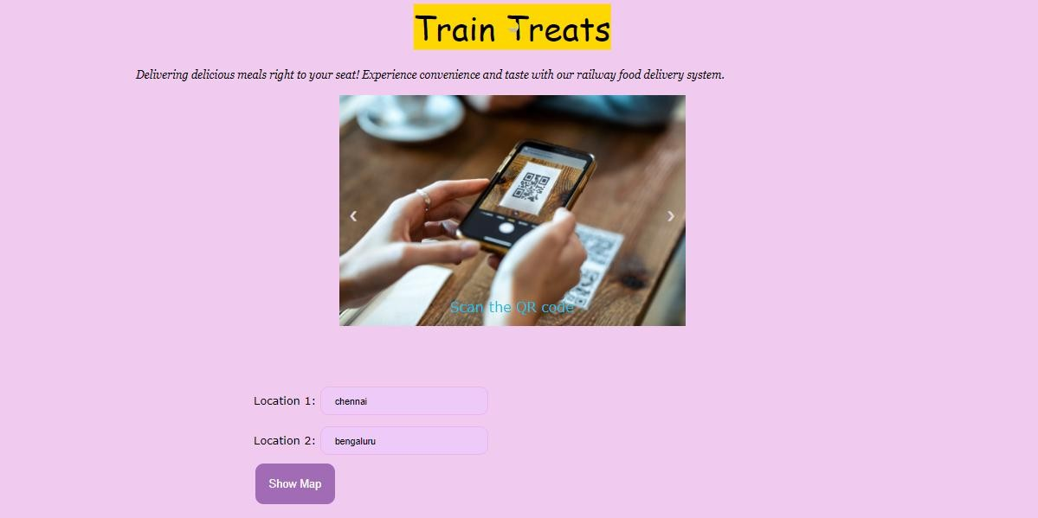

**Fig.3.1** Design of Module 1

## Module – II

The second module retrieves the eateries that are close to the two locations and shows the map according to the user's inputs.

.

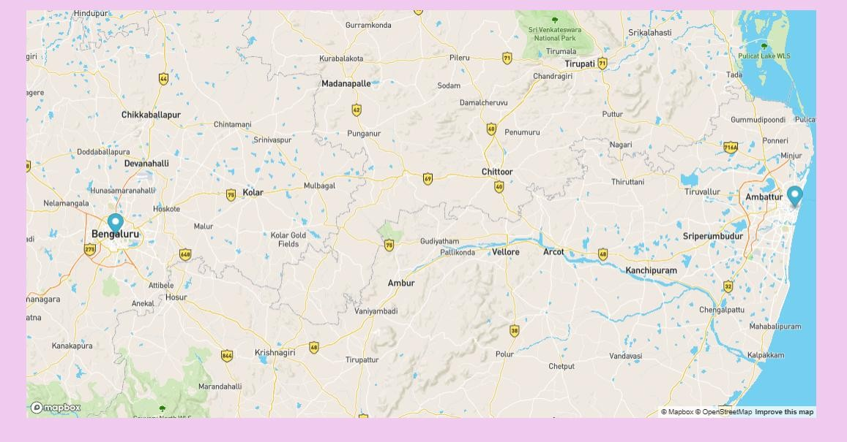

**Fig.3.2** Design of Module –II Displaying the Map

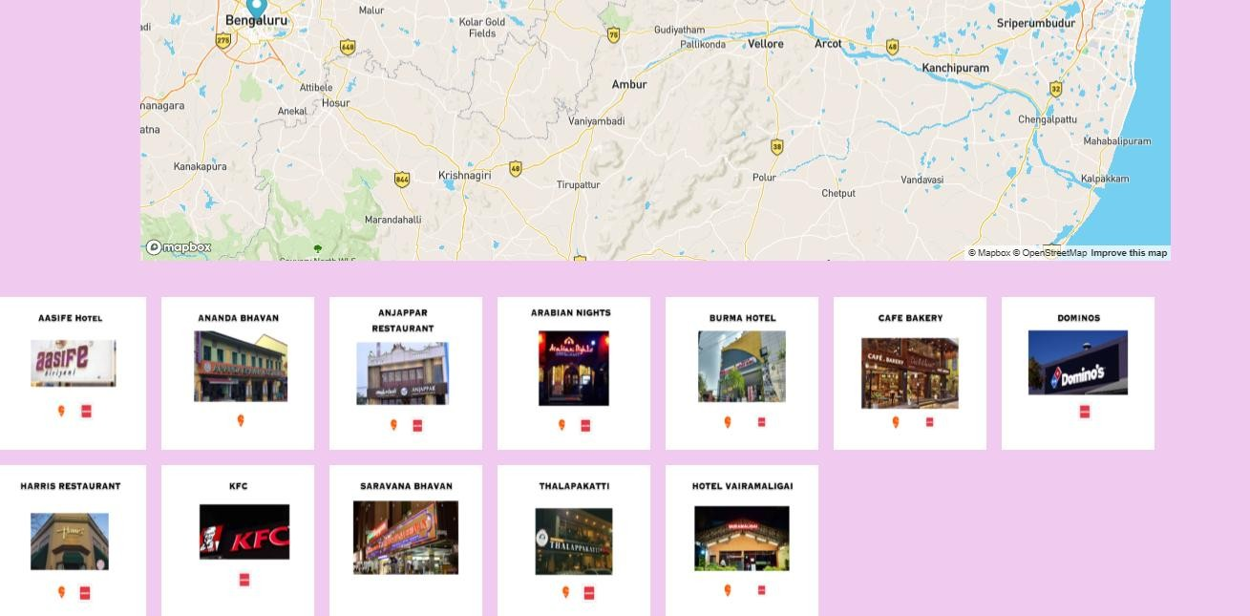

**Fig.3.3** Design of Module –II Displaying the Restaurants

**Module – III**

The user can place food orders in the third module, which lists the menu cards for the restaurants they've chosen. When the user clicks the calculate button beneath the menu card, the total amount to be paid is shown.

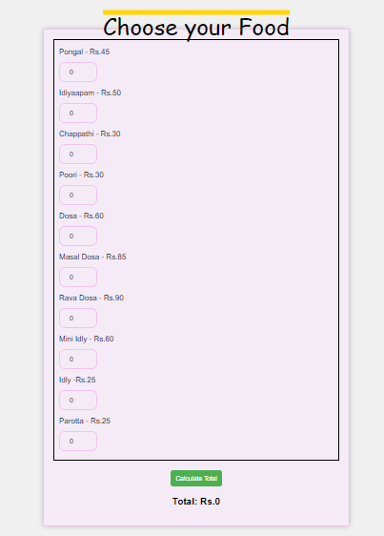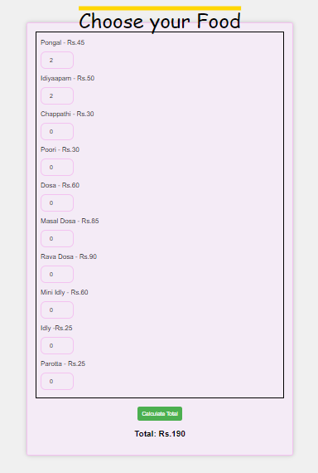

**Fig 3.4** Design of Module-III **Fig 3.5** Design of Module – III Displaying the menu card Displaying the total amount

## Conclusion:

Thus, the railway food ordering application's abstract, introduction, customer survey, customer journey map, empathy map, block diagram of the suggested solution, and module that have been finished to date were examined and documented.